GIT ASSIGNMNETS

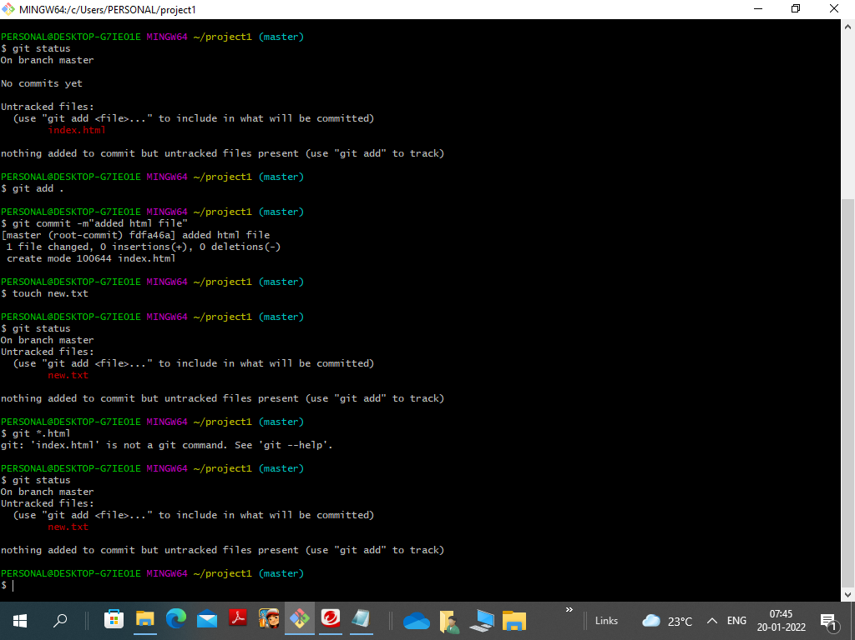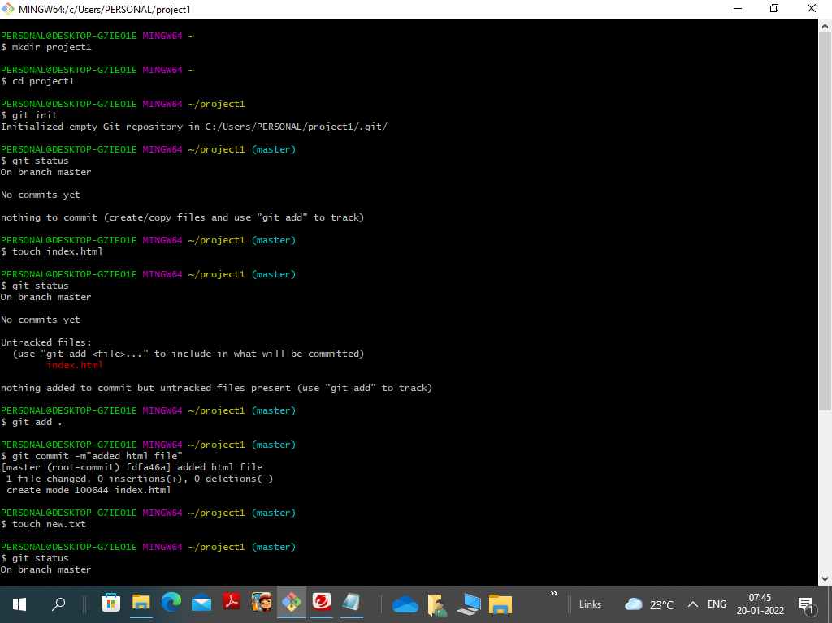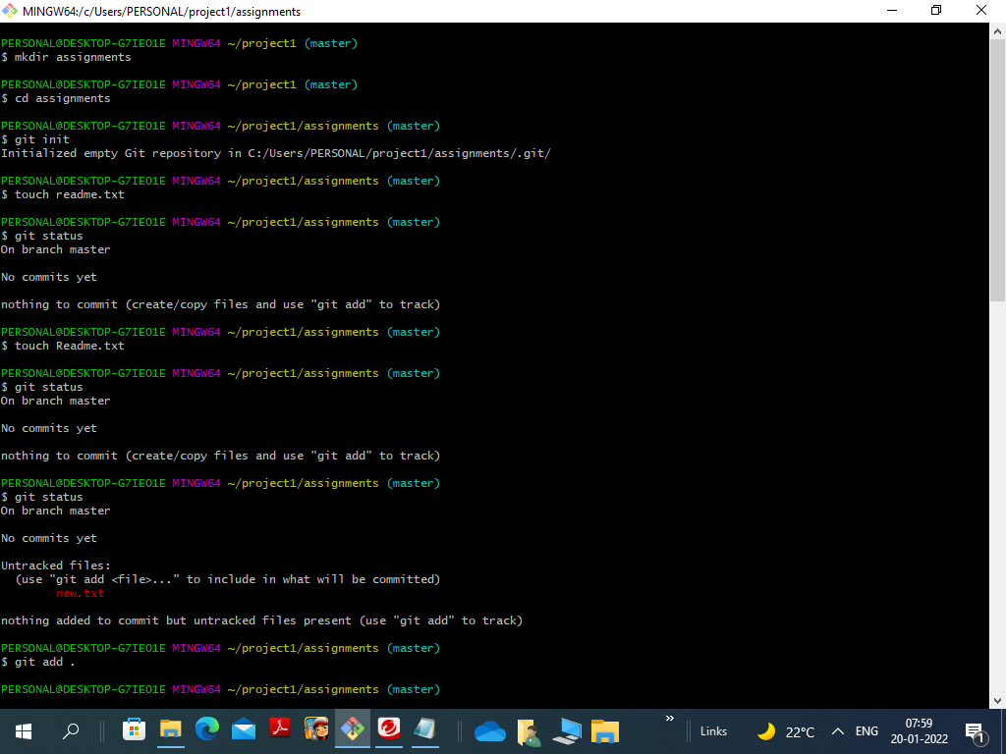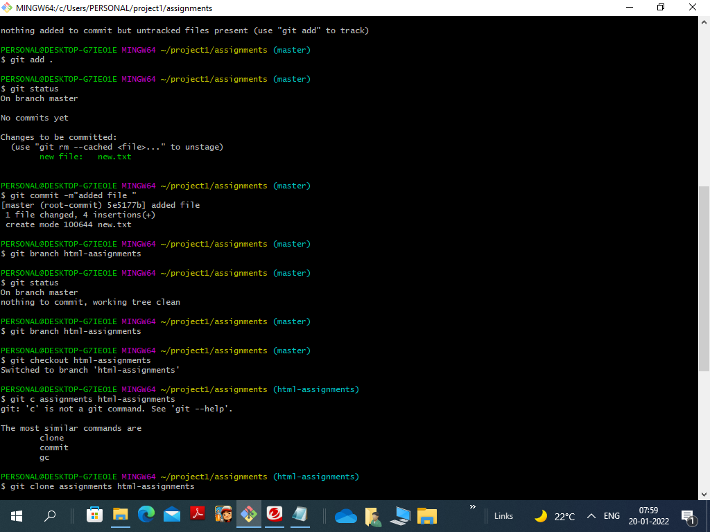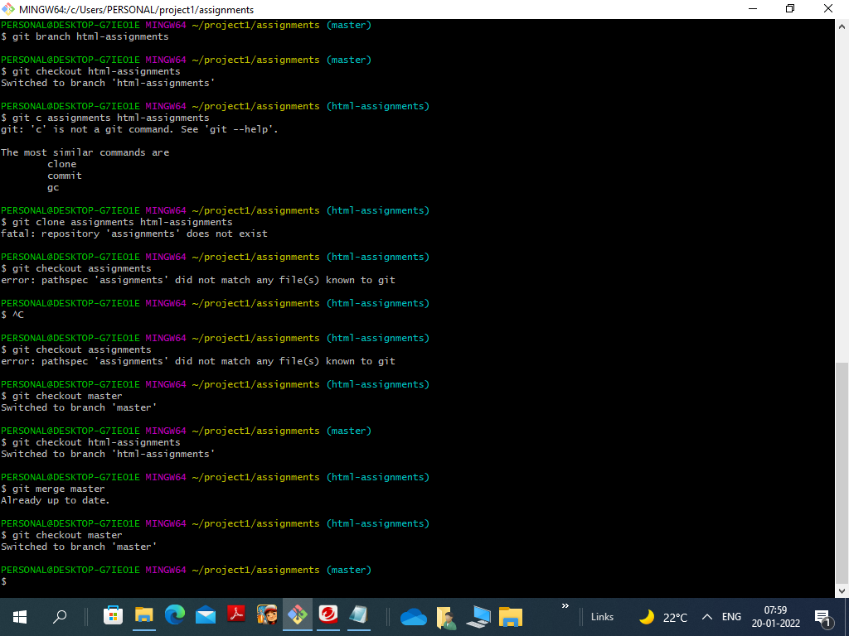

PERSONAL@DESKTOP-G7IE01E MINGW64 ~/project1 (master)

$ mkdir assignments

PERSONAL@DESKTOP-G7IE01E MINGW64 ~/project1 (master)

$ cd assignments

PERSONAL@DESKTOP-G7IE01E MINGW64 ~/project1/assignments (master)

$ git init

Initialized empty Git repository in C:/Users/PERSONAL/project1/assignments/.git/

PERSONAL@DESKTOP-G7IE01E MINGW64 ~/project1/assignments (master)

$ touch readme.txt

PERSONAL@DESKTOP-G7IE01E MINGW64 ~/project1/assignments (master)

$ git status

On branch master

No commits yet

nothing to commit (create/copy files and use "git add" to track)

PERSONAL@DESKTOP-G7IE01E MINGW64 ~/project1/assignments (master)

$ touch Readme.txt

PERSONAL@DESKTOP-G7IE01E MINGW64 ~/project1/assignments (master)

$ git status

On branch master

No commits yet

nothing to commit (create/copy files and use "git add" to track)

PERSONAL@DESKTOP-G7IE01E MINGW64 ~/project1/assignments (master)

$ git status

On branch master

No commits yet

Untracked files:

(use "git add <file>..." to include in what will be committed)

new.txt

nothing added to commit but untracked files present (use "git add" to track)

PERSONAL@DESKTOP-G7IE01E MINGW64 ~/project1/assignments (master)

$ git add .

PERSONAL@DESKTOP-G7IE01E MINGW64 ~/project1/assignments (master)

$ git status

On branch master

No commits yet

Changes to be committed:

(use "git rm --cached <file>..." to unstage)

new file: new.txt

PERSONAL@DESKTOP-G7IE01E MINGW64 ~/project1/assignments (master)

$ git commit -m"added file "

[master (root-commit) 5e5177b] added file

1 file changed, 4 insertions(+)

create mode 100644 new.txt

PERSONAL@DESKTOP-G7IE01E MINGW64 ~/project1/assignments (master)

$ git branch html-aasignments

PERSONAL@DESKTOP-G7IE01E MINGW64 ~/project1/assignments (master)

$ git status

On branch master

nothing to commit, working tree clean

PERSONAL@DESKTOP-G7IE01E MINGW64 ~/project1/assignments (master)

$ git branch html-assignments

PERSONAL@DESKTOP-G7IE01E MINGW64 ~/project1/assignments (master)

$ git checkout html-assignments

Switched to branch 'html-assignments'

PERSONAL@DESKTOP-G7IE01E MINGW64 ~/project1/assignments (html-assignments)

$ git c assignments html-assignments

git: 'c' is not a git command. See 'git --help'.

The most similar commands are

clone

commit

gc

PERSONAL@DESKTOP-G7IE01E MINGW64 ~/project1/assignments (html-assignments)

$ git clone assignments html-assignments

fatal: repository 'assignments' does not exist

PERSONAL@DESKTOP-G7IE01E MINGW64 ~/project1/assignments (html-assignments)

$ git checkout assignments

error: pathspec 'assignments' did not match any file(s) known to git

PERSONAL@DESKTOP-G7IE01E MINGW64 ~/project1/assignments (html-assignments)

$ ^C

PERSONAL@DESKTOP-G7IE01E MINGW64 ~/project1/assignments (html-assignments)

$ git checkout assignments

error: pathspec 'assignments' did not match any file(s) known to git

PERSONAL@DESKTOP-G7IE01E MINGW64 ~/project1/assignments (html-assignments)

$ git checkout master

Switched to branch 'master'

PERSONAL@DESKTOP-G7IE01E MINGW64 ~/project1/assignments (master)

$ git checkout html-assignments

Switched to branch 'html-assignments'

PERSONAL@DESKTOP-G7IE01E MINGW64 ~/project1/assignments (html-assignments)

$ git merge master

Already up to date.

PERSONAL@DESKTOP-G7IE01E MINGW64 ~/project1/assignments (html-assignments)

$ git checkout master

Switched to branch 'master'

PERSONAL@DESKTOP-G7IE01E MINGW64 ~/project1/assignments (master)

$